Poster concepts and descriptions
Poster #1
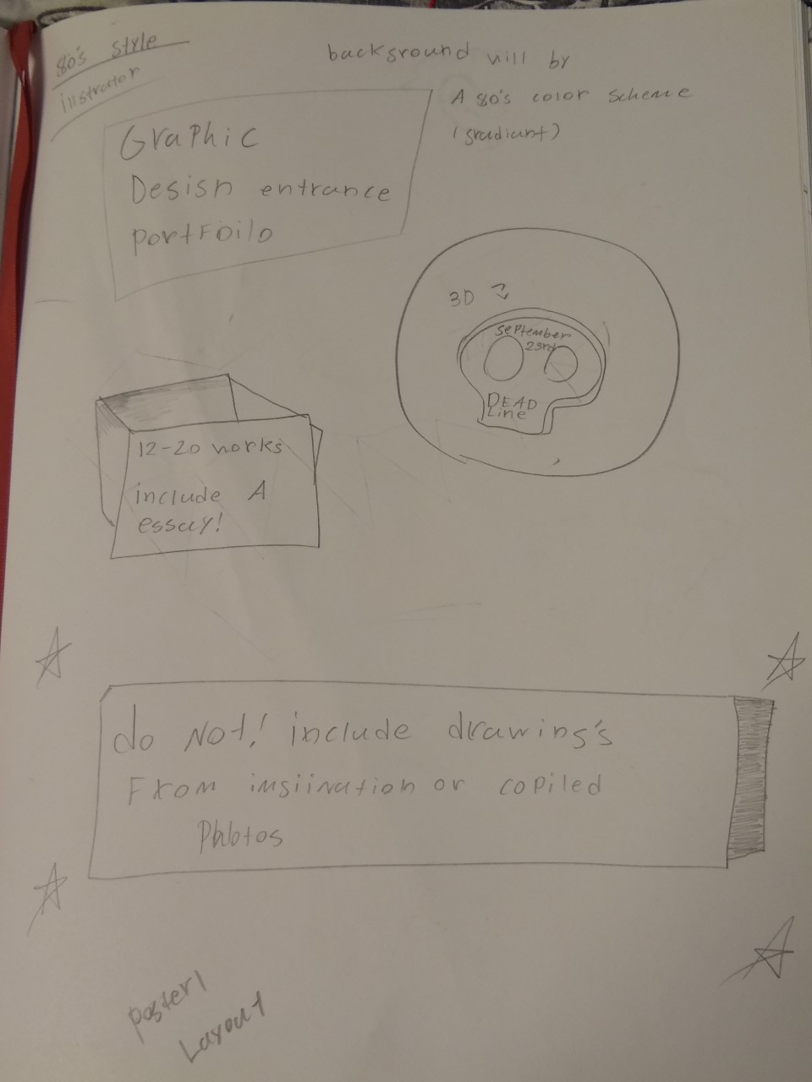
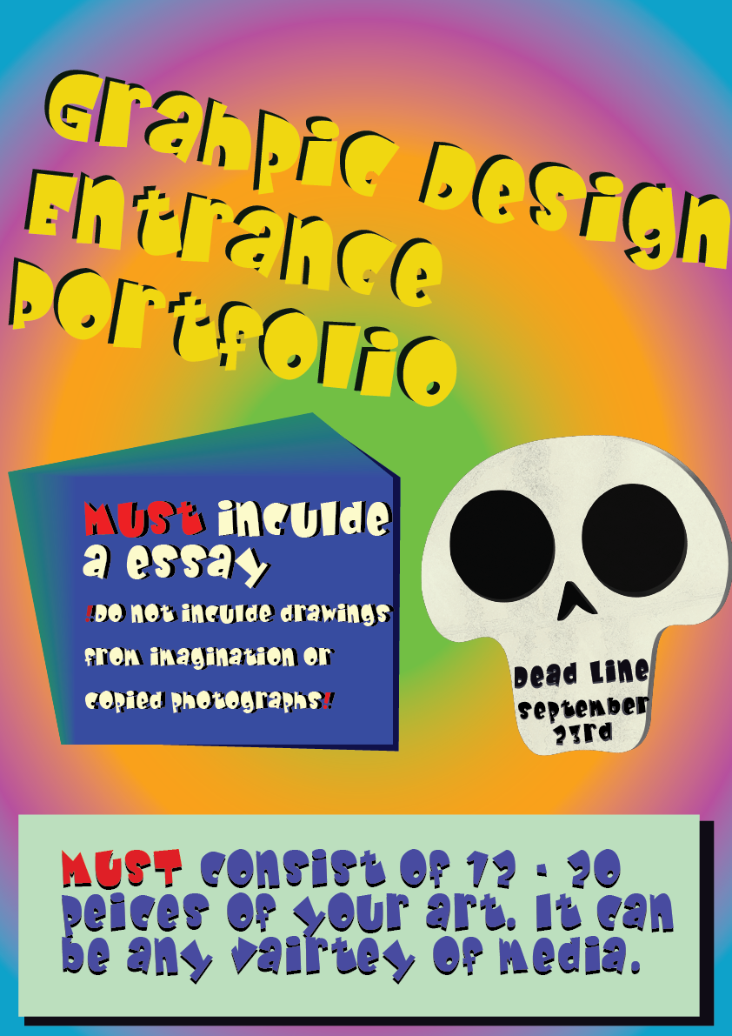
Poster concept 1, layout 1 (prototype) (illustrator)
- This is one of the less ambitious layouts, being less cluttered.

- This poster will be is colorful, with a 80’s theme in the background in a gradient style
- The hierarchy on this poster is 1, the title, 2 the warning of not including drawings from imagination or copied images, 3 the deadline skeleton, and 4, “MUST include a essay” block

- I added darker colors behind the blocks of color, to add depth.

- I wanted to use a consistent font, to give reference to the 80’s theme. Consistent font helps with keeping the poster uncluttered.

- There are some things I would like to tweak, such as font placement. And the harshness of edges in the poster.

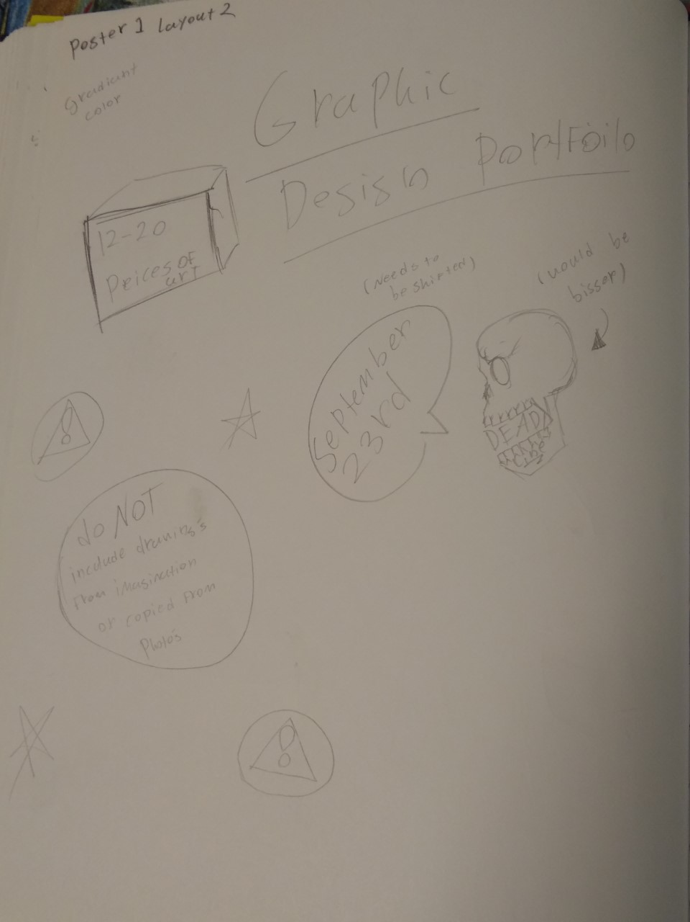
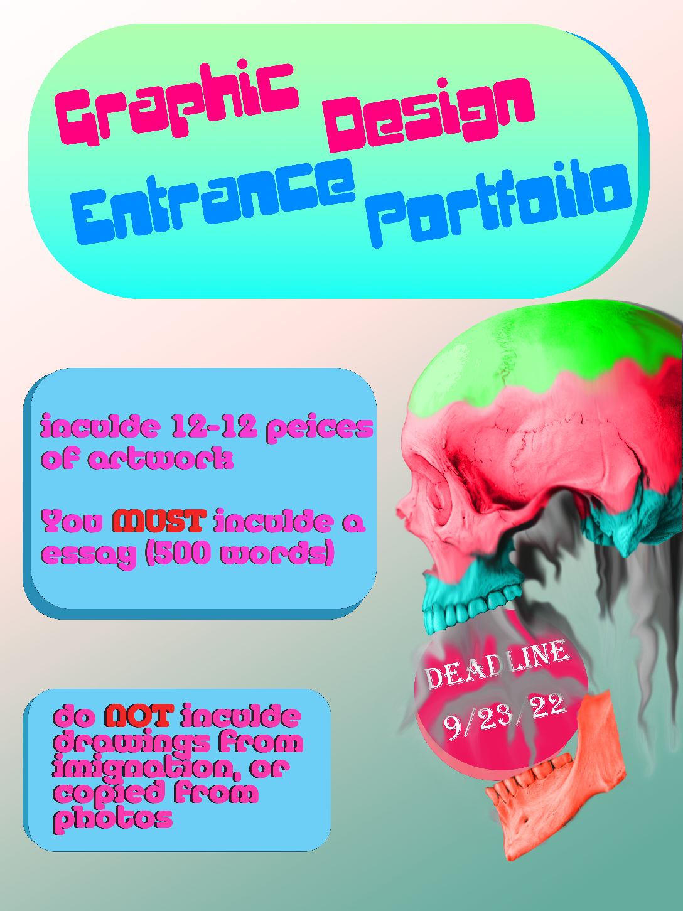
Poster 1, layout 2 (prototype) (photoshop)

- This one I believe looks better due to the realistic skull. Which I’m proud of. I gave it a smoky shadow look

- The hierarchy in this design is definitely the skull and the title of the poster.
- These being quick prototypes, they are rough around the edges. Although I do want to keep the realistic skull as a feature of the final poster if I do end up choosing this concept.

- I didn’t go with a repeated font for this poster, since I feel that the “deadline” and title of the poster should draw the eye. As well as the softer font for the other information. Still important but shouldn’t slap someone in the face with a sharp/harsh font.

- I feel that the bubbly frames around the title and information helps draw the eye. So does the sharp edges as well, but I feel like it is something that is seen more often instead of something softer.

Both designs
- Both designs have skulls and bright colors, which I feel is a good theme contrast. Also, I just wanted to have fun with the words “dead line”. The skull imagery is a bit of a pun or a metaphor.

- I haven’t used photoshop or illustrator in a few years, so I’m extremely rusty.

Poster #2
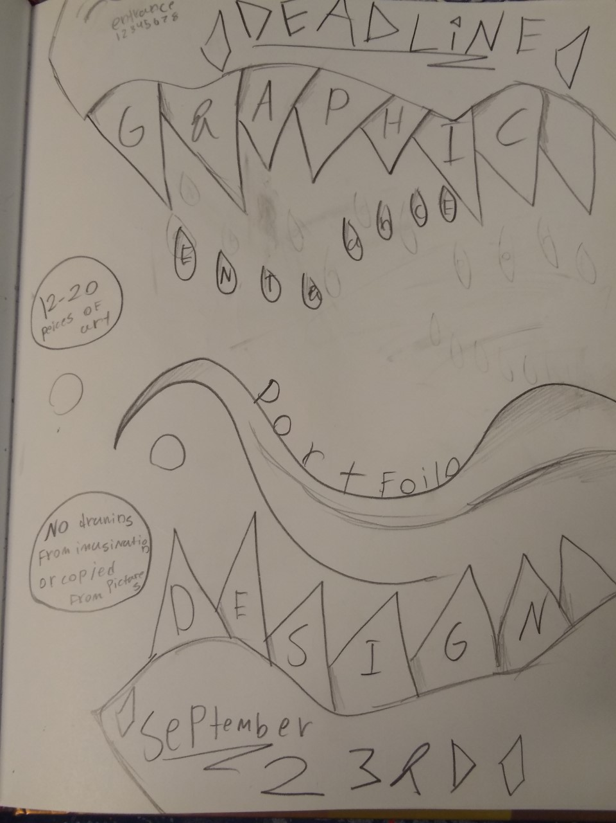
Poster 2, layout 1, (sketch)

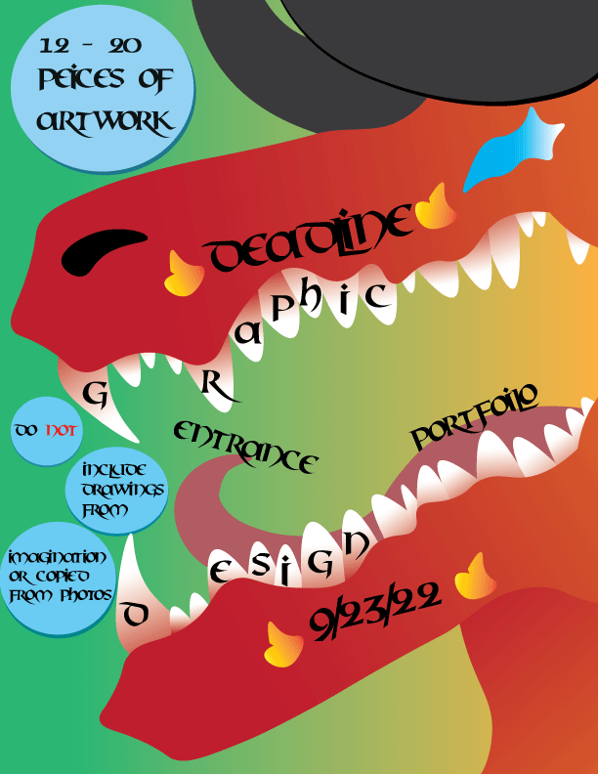
Poster 2, layout 1 (prototype)

Hierarchy
- The main hierarchy is the huge dragon, of course. Being the biggest and most obvious thing. The second thing being the “deadline” text and the date. Third being the “12 – 20 pieces of artwork” text, fourth being the “Graphic design” and “entrance” portfolio test. Lastly is the other bits of information in the circles.

Details
- I’m super happy with how the dragon and his teeth turned out. I used the gradient tool to add some depth to the teeth, and it creates a effect of shadows on them. So it worked out well.
- I’m unhappy with how I couldn’t get the “entrance portfolio” text to click the path of the tongue. I tried for a hour, trying different path ways and they all looked pretty awful. I’m sure once I get more practice, it’ll be much better. Like I’ve said before, I’m extremely rusty, but I do try my best.
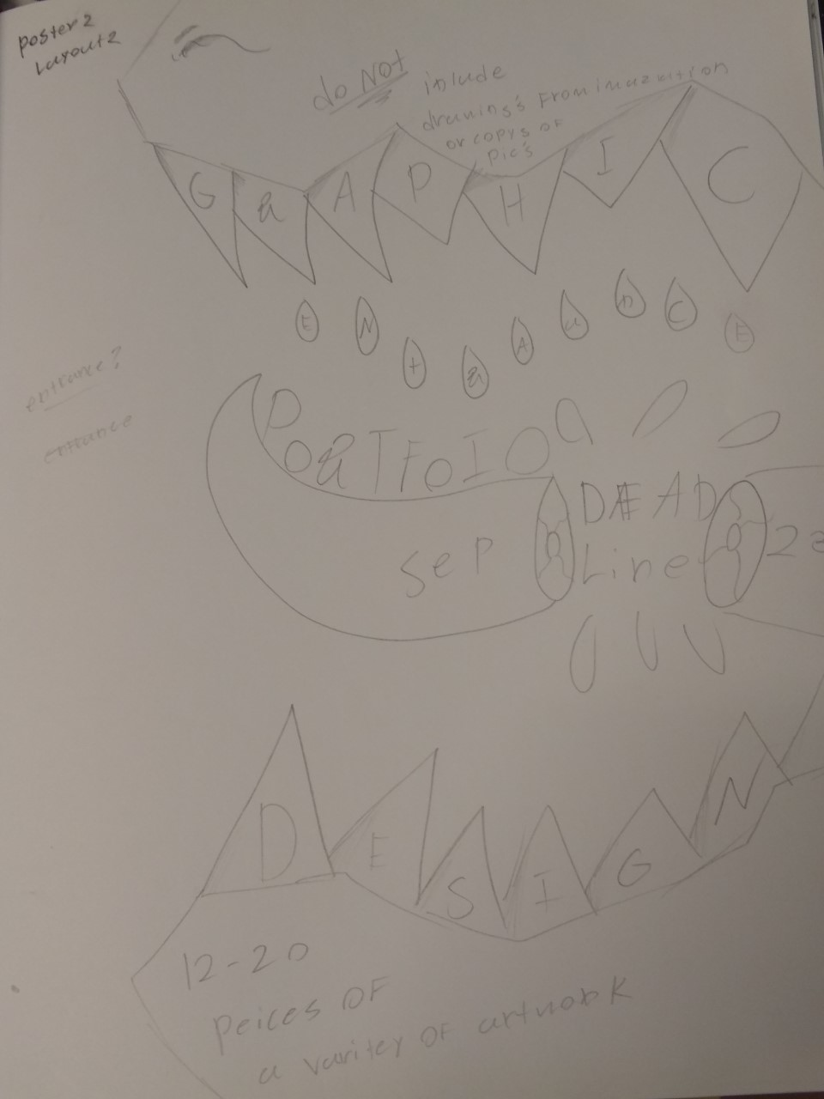
Poster 2, layout 2 (sketch)

Hierarchy
- The hierarchy in this layout is the same as layout 1, The dragon head. The second being the teeth, and thirdly being the tongue. The text hierarchy being “Graphic design” on the teeth, “Portfolio” on the tongue, “deadline” and it’s date in and by the sides of the split in the tongue. Fourth being the information texts on the top and bottom of the mouth. Finally is “entrance” in the drops of saliva coming off the teeth.

- This layout this pretty much the same as the previous one, other in the split in the tongue, which some extra details.

- The only thing I would change is the placement of the “Do NOT include drawings from imagination or copied from photos” to the bottom of the mouth.

